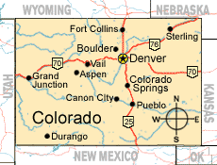

Colorado State Laws 12-44-109 and 12-44-110

- $50 Maximum liability for any baggage or personal property left at Hotel for safekeeping
(at no charge)

- $200 Maximum liability for an in-room loss, unless there was an agreement with the Hotel to assume greater liability

- These liability limits only apply if you can prove the Hotel was the cause of the loss (i.e. left door open/unlocked, gave property to wrong person, lost or damaged property WHILE the Hotel had custody of it, room key given to non-registered guest etc.)

